Roll No 2310030019

9)Real time Search

Backend

Frontend

Output:

3)Product List with Search

Backend

FrontEnd

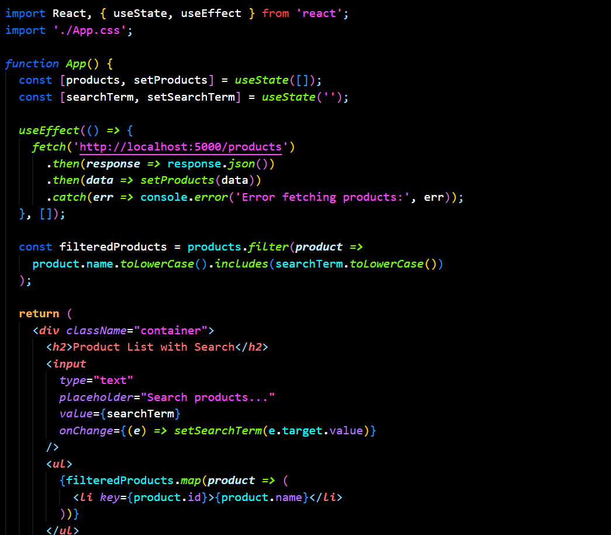

Output:

